The Masters of Photojournalism:
Comparing the works of Sebastiao Salgado and James Nachtwey

When aspiring to become an effective photojournalist, any student of the art must understand how to make great images. One of the most effective ways of doing this is learning through the close examination of work by the world’s greatest photographers. In this arena, the photojournalists Sebastiao Salgado and James Nachtwey undoubtedly hold the highest positions. A title not earned easily, the images presented by these photojournalists repeatedly bring back the atrocities and circumstances we could not witness in our own lives at home. Both photographers, uniquely similar in background, yet different in photographic style, have many lessons to share with the upcoming photojournalists of the future. With close examination of where they came from, how they work, and how we can apply it to our own photography, we as students of photography have almost limitless lessons we can learn and apply to our own photographic skill.
To begin understanding these photographers, it is critical to understand their origins and how they became photojournalists. Sebastiao Salgado originally studied economics in both Paris and the U.S. before choosing to change his career to photojournalism. Salgado made the change when he realized that his economic reports could not properly communicate the sights he witnessed when on a trip to Africa for the International Coffee Organization (Witness). Similarly, James Nachtwey finished his college career as an art history and political science student. Only after observing pictures from the Vietnam War while working on a merchant ship did Nachtwey choose to change professions and pursue photojournalism (About.com).
While some may find it surprising that both of these now world-renowned photographers did not begin their career with intentions of becoming photojournalists, it is not to say that their respective educations are not reflected in their photography (Witness). Changing careers after their job induced situational interaction prompted some of the most communicative images seen to this day (Salon.com). By each constantly using their education to bring attention to their subjects, these photographers have illuminated conditions some would have preferred remain in the dark to the eye of the public. These actions speak highly of their characters as both saw the horror at hand and knew something had to be done, and then took it amongst themselves to do the job (About.com). However, before either could begin creating their powerful images, each had to learn photography from the beginning.
Training themselves, Salgado and Nachtwey began leaning how to make images. Choosing different paths, Salgado began by borrowing his wife’s camera while on his trip to Africa, where he began shooting people caught in Africa’s transition (Witness). Nachtwey began his training by studying the current photographic masters and reading books on technique (About.com). He then practiced his skill in his spare time as a news film editor’s apprentice until he was able to secure his first job as a photographer for a local New Mexico newspaper. After each built their skills, both began traveling to explore the tragedies they had seen during their prior careers. As each progressed, Salgado and Nachtwey developed different photographic styles for which they would use to communicate their ideas to the sheltered world.
While each of Salgado’s and Nachtway’s collective works take the viewer to a place in which they are unfamiliar, both chose different ways to convey the occurrences they witnessed. In all of the places they visited, images of men, women, children, life, and death were available for capture, however each chose to make pictures of different content to communicate their messages.
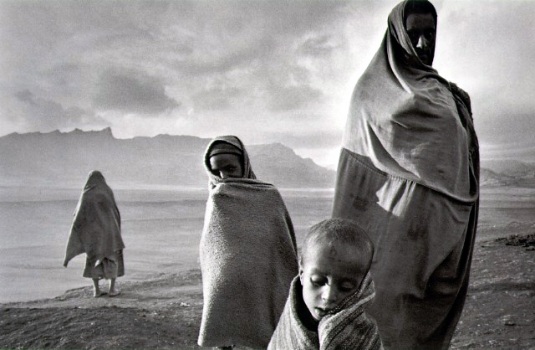
In his book Migrations, Sebastio Salgado chose an artistic style of photography for a majority of his work, which consisted of creative use of light and shadow to create a picture with deeper meaning. In this picture, Salgado used the light behind the subject to create a halo effect, which makes the picture more visually appealing. While the subjects of this picture are being forced to move, Salgado’s design style makes the picture more interesting to the viewer, which results in more people viewing the picture. Drawn to the pictures use of light, viewers are also exposed to the emotion expressed by the subjects, which helps them comprehend their struggle and Salgado communicate his message.
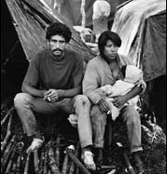
Salgado, while also witness to the death of his subjects in Migrations, prefers to promote pictures of life, as many of his images are comprised of children, including a number of images where women are breast feeding their young. I found this to work well with the topic of his book, as the title inherently means movement, which interpretation yields as the continuation of life. Had Salgado chose to focus on images of death, it would not have been effective for the book since death is a terminating event, from which there is nowhere to move to. Overall, his style of chronicling change provides viewers with images that are moving, emotional, and visually appealing. Salgado’s artistic style achieves his goal of communicating his subject’s struggle while not offending or sickening his viewers.
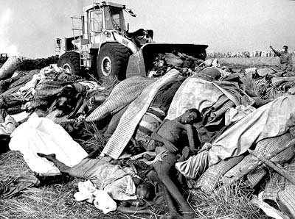
For his photography, James Nachtwey has chosen a documentary style because he feels it better communicates the true conditions in which he finds his subjects (About.com). Proclaiming himself as an Anti-War Photographer, Nachtwey wants his images to speak of the horrors created by war and motivate his viewers to demand change (PBS). In his recent book Inferno, Nachtwey presents difficult images that push the viewer’s threshold to the point of disgust. In this image, a bulldozer collects bodies from a field in Zaire. While this image is technically perfect, for some it may be too emotionally difficult to handle and promote its dismissal from the mind. One might say, “how could something like that be true…it is beyond comprehension” and move quickly away from the picture. If this is the case, Nachtwey has failed because he has alienated the people who can promote change, his viewers. While not all of Nachtwey’s images are as potent as the one above, many people find his work difficult to view. Although, this is an acceptable risk for Nachtwey as he wants to deliver images that will upset emotions and spark desire for action.
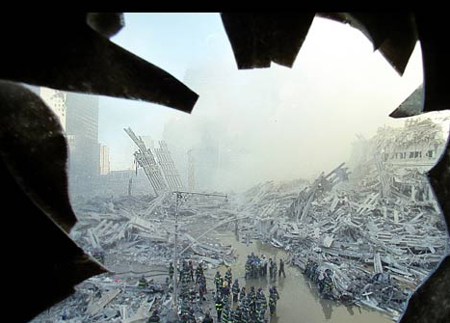
However, Nachtwey’s style is not limited to images of disgusting events. He also uses his documentary style to capture scenes from unusual perspectives. This image, captured from inside a building at ground zero, uses the broken glass as a frame to encompass the familiar scene of firefighters digging through the World Trade Center wreckage. By using this frame, Nachtwey has added a new angle to a common picture making his image more interesting and visually appealing. Using these documentary photography techniques, Nachtwey lets his images speak for themselves to communicate the horror of the situation. Nachtwey would rather his viewer be moved by his picture’s content rather than their composition or exposure.
While both of these photographers use different styles to create their images, both are effective communicators of the events they witness. Be it artistic or documentary, both of these styles succeed in the end by delivering powerful images that enlighten, scare, upset, and please their viewers. Both Salgado and Nachtwey are masters of these styles and the study of their applications of them in these images is critical to any aspiring photography student.
With the quality of Salgado and Nachtwey’s images, almost an infinite number of lessons can be learned about representing the human condition. Salgado’s use of light has been particularly inspiring as it demonstrated how the image of a person could be changed simply by the surrounding light. Echoes of Henri Cartier-Bresson’s decisive moment theory can be heard dictating waiting for that perfect light to create the picture. With Salgado’s lesson, even a struggling group of people can be made peaceful and harmonious with proper lighting.
James Nachtwey also provided a useful lesson in the afterward to Inferno, where he states, “I began my career searching for the moment of highest drama that would convey the essence of the story in a single image. I pursued those moments on gut instinct and raw adrenaline, almost to the exclusion of the supporting details of a given story. With Inferno I am seeking a something deeper, and broader treatment of events – something with a narrative, cinematic quality; something that possesses not only structure integral to the single image, but also the connections between images. It is an attempt to go beyond a collection of the so-called “Best Images” and replace it with the flow of events; ongoing, real, existing beyond the presence of photos.” This is a critical statement and lesson for all photojournalists as it reminds us to look beyond the single best shot of a subject and find the entire truth in a circumstance or event. All too often we do only what the assignment asks and do not think about the details that made the event possible. We try to find only one perfect image to sum up the event, when in reality multiple images are needed to tell the entire story. Practicing this lesson will illuminate our viewers to a higher level of understanding by seeing these “process of events” images. Not only will the topic become better understood, but the conditions faced by people making the event occur will be illuminated.
From these Masters of Photojournalism, aspiring photographers can learn an unlimited amount of knowledge. Salgado and Nachtwey even prove that one need not even be a photojournalism student in school to learn how to make good pictures. What they do prove however is that you must know your subject, be able to portray them in a fashion and style that will truthfully communicate the message you are attempting to send to viewers, and know how to properly use light, composition, and exposure to produce great photographs. With the application of these skills and concepts to our photography, there is nothing stopping us but ourselves from joining the ranks of Salgado and Nachtwey among the Masters of Photojournalism.

Sources Cited

Nachtwey, James. Inferno
© 1999 Phaidon. London

Salgado, Sebastio. Migrations
© 2000 Aperture. New York

Light, Ken Witness in our Time
© 2000 Ken Light. Washington

Ursula Gropper Associates. James Nachtwey 11/1602;
http://www.ursulagropper.com/nachtwey/nachtwey.html

About.com. James Nachtwey, 11/1602;
http://photography.about.com/library/weekly/aa092401a.htm

PBS Online NewsHour Conversation with James Nachtwey 11/16/02;
http://www.pbs.org/newshour/gergen/jan-june00/nachtwey_5-16.html

Terra.com Sebastio Salgado 11/16/02;
http://www.terra.com.br/sebastiaosalgado/

Salon.com James Nachtwey “Inferno” Portfolio 11/16/02;
http://archive.salon.com/people/portfolio/2000/04/10/inferno/index.html

Time. Shattered 11/16/02;
http://www.time.com/time/photoessays/shattered/

Salon.com James Nachtwey “Inferno” 11/16/02;
http://dir.salon.com/people/feature/2000/04/10/inferno/index.html?pn=1

Profotos.com Sebastio Salgado 11/16/02;
http://www.profotos.com/education/referencedesk/masters/masters/sebastiosalgado/sebastiosalgado.shtml

